Concurrentieonderzoek project BBQ

[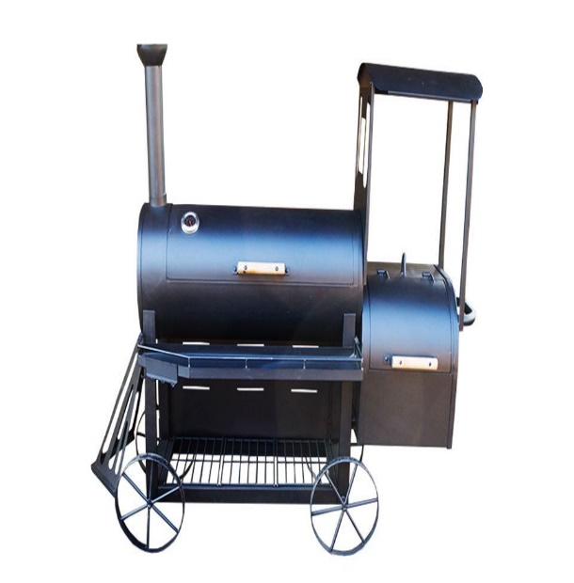](https://www.google.com/url?sa=i&url=https%3A%2F%2Fwww.fonteyn.nl%2Fbarbecues%2Fhoutskool-barbecue%2Ffonteyn-locomotief-barbecue&psig=AOvVaw3GHl3WtofwBDwYKCftGC8D&ust=1590051700766000&source=images&cd=vfe&ved=0CAIQjRxqFwoTCJiWhKmKwukCFQAAAAAdAAAAABAj)[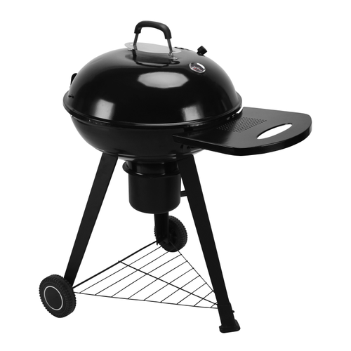](https://www.google.com/url?sa=i&url=https%3A%2F%2Fwww.praxis.nl%2Ftuin-buitenleven%2Fbarbecue%2Fhoutskool-barbecue%2Fg75%2F&psig=AOvVaw3GHl3WtofwBDwYKCftGC8D&ust=1590051700766000&source=images&cd=vfe&ved=0CAIQjRxqFwoTCJiWhKmKwukCFQAAAAAdAAAAABAQ)

[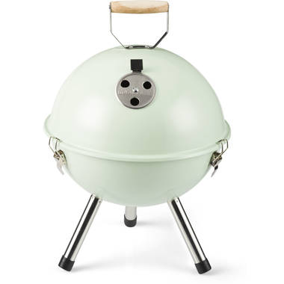](https://www.google.com/url?sa=i&url=https%3A%2F%2Fwww.blokker.nl%2Fc%2Ftuin%2Fbarbecues-barbecuetafels-en-accessoires%2Fbarbecues%2F945179&psig=AOvVaw3GHl3WtofwBDwYKCftGC8D&ust=1590051700766000&source=images&cd=vfe&ved=0CAIQjRxqFwoTCJiWhKmKwukCFQAAAAAdAAAAABAp)[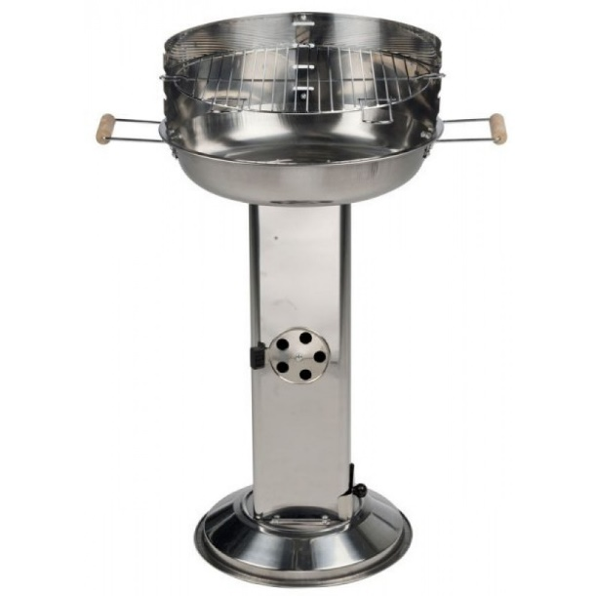](https://www.google.com/url?sa=i&url=https%3A%2F%2Fwww.debarossa.nl%2Fproduct%2Fbbq-roestvrij-stalen-barbecue%2F&psig=AOvVaw3GHl3WtofwBDwYKCftGC8D&ust=1590051700766000&source=images&cd=vfe&ved=0CAIQjRxqFwoTCJiWhKmKwukCFQAAAAAdAAAAABAc)[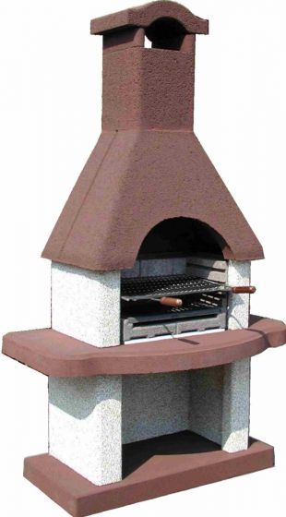](https://www.google.com/url?sa=i&url=https%3A%2F%2Fwww.intergard.eu%2Fbarbecue-beton-bbq&psig=AOvVaw3GHl3WtofwBDwYKCftGC8D&ust=1590051700766000&source=images&cd=vfe&ved=0CAIQjRxqFwoTCJiWhKmKwukCFQAAAAAdAAAAABAW)[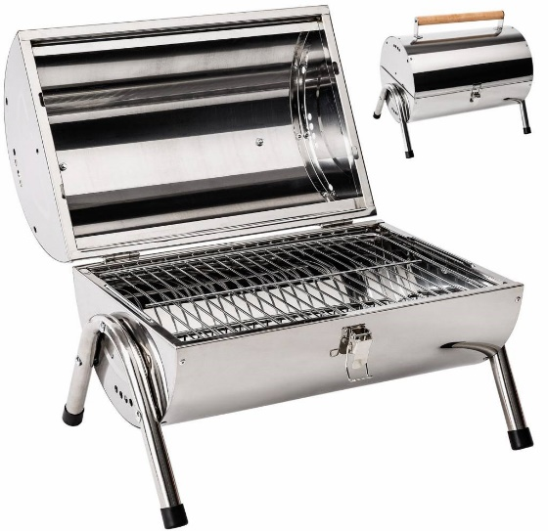](https://www.google.com/url?sa=i&url=https%3A%2F%2Fwww.tradeshopping.nl%2Fcamping-bbq-barbecue-grill-in-roestvrij-staal.html&psig=AOvVaw3GHl3WtofwBDwYKCftGC8D&ust=1590051700766000&source=images&cd=vfe&ved=0CAIQjRxqFwoTCJiWhKmKwukCFQAAAAAdAAAAABAE)